Dr. Timothy Grayson is the Director of the Strategic Technology Office (STO) at DARPA. In this role, he leads the office in development of technologies to enable soldiers to field, operate, and adapt distributed, joint, multi-domain combat capabilities. Dr. Grayson came to STO in 2018 from a diverse career in government and industry, including as an entrepreneur, and service in the intelligence community as a Senior Intelligence Officer. He holds a PhD in Physics from University of Rochester, where he specialized in quantum optics, and a BS in Physics from University of Dayton with minors in mathematics and computer science.

At [AI World Government](https://www.aiworldgov.com/) in Alexandria, Va., Oct. 18-19, Dr. Grayson will deliver a keynote address on Managing the Complexity of Adopting AI, focusing on the design of enterprise interconnected architectures. This is akin to designing the Industrial Internet of Things in the commercial world and is characterized at DARPA as Mosaic Warfare. Dr. Grayson recently spent a few minutes talking to AI Trends Editor John P. Desmond about the work.

**AI Trends: Can you outline DARPA’s vision for Mosaic Warfare and the Industrial Internet of Things (IIoT) within that? What is the role of AI in that vision?**

**Dr. Grayson**: We use the term ‘mosaic’ in the context of what we call Mosaic Warfare. If you look at where the DOD has been heading, it’s moving toward what I’ll call a system of systems type of approach. Instead of having the weapons, the comms, the sensors, the decision aids, all tightly integrated together into one platform, they’re very disaggregated.

I can find whatever sensor is the best for the job and whatever weapon is the best for the job, and don’t care about what platform they’re on. That’s been the trend, not just at DARPA, but across the department. In addition, where we’re going is trying to make that system of systems architecture process much more adaptable and agile, one of the terms we often use with mosaic is a so-called ‘monolith busting.’

So a system of systems is busting up monolithic platforms into these distributed, disaggregated capabilities. What we’re doing with Mosaic is preventing the need to effectively hand-engineer every single one of those systems of systems architectures—so Mosaic is busting monolithic architectures as well.

Today, if someone says, ‘Hey, I want to swap out sensor A and bring in sensor B.’ That’s a manual engineering process to do that integration. We’re trying to create the tools and the infrastructure to make that composition of architectures much easier and faster, so that ultimately it doesn’t even require engineers to be involved in designing things. It’s almost more of an operator saying, ‘Here’s the architecture that I want.’ And then technician-level people use Mosaic tools to configure it and make it so. It greatly reduces the time required to create very complex, machine-centered, cyber-physical architectures.

While it’s not in our core mission, from a dual-use perspective there’s an analogy to the commercial world with the so-called Industrial Internet of Things or IIoT. Mosaic Warfare is helping the military deal with a very heterogeneous mix of different domains, different military Services, different ages of equipment, and legacy systems. That’s a very similar problem that the commercial IIoT world is dealing with in areas such as the smart grid, advanced manufacturing, distributed supply chains and advanced transportation.

All of those market verticals trying to get to new levels of digitization and modernization through the IIoT have this problem of building systems and systems architectures without throwing away the legacy, in-place, really expensive electromechanical equipment that still works.

We have billions and billions of dollars of sunk cost in legacy equipment. So, the IIoT world needs to be able to digitize and modernize over this very heterogeneous fabric of legacy stuff. And that’s effectively exactly what we’re trying to do for the DOD. If instead of thinking about a sensor on an aircraft and some military tactical radio and instead consider some kind of voltage transducer on a smart grid and the SCADA [Supervisory Control and Data Acquisition] system used to control it—that’s a very analogous kind of problem.

AI can help us compose these systems of systems architectures, reconfigure them, integrate new capabilities and very quickly modify their functions, modifying how things collaborate and act together. AI is wonderful in the sense of the options it provides. It’s also horrible in the complexity that it creates.

In the ‘execution’ portion of our portfolio, AI is applied all up and down what I might call a cognitive or decision stack. At a very high level is macro-level decision-making. What are my objective functions? What assets do I want to use to actually compose into one of these systems of systems architectures? What specific tasking or control actuation do I want to give to each of those things?

You just start moving down that stack of decision-making, until ultimately the decision-making turns more into actuation. For instance, if it’s an aircraft, the actual flying and maneuvering of the aircraft and how you’re going to move the control surfaces, is a decision process. How I’m going to control a multifunction sensor that has a bunch of different modes to it, is a decision process.

So at each of those steps of decision, the AI ends up coming in as a decision aid to help the humans explore options.

As you move down that stack, the AI is more directly controlling things. It might actually be flying and maneuvering the aircraft itself while the human is making the high-level battle management decisions. But at the end of the day, I would say for us, AI is first and foremost about managing that complexity.

**A number of ethical frameworks that attempt to guide the use of AI have been put forward in the past several years. Which ethical framework does DARPA operate within, and is there a way you can assess what impact it’s having?**

The terminology we use tends to be a ‘human-on-the-loop.’ So very few of the AI applications that we’re developing are designed to run fully autonomously. You can think of our AI mostly as falling into the category of decision aids.

We often refer to a human-machine symbiosis, where it’s a partnership and where the AI is doing part of the job that fits well for a computer, while the human compliments that with more cognitive, open-ended types of efforts. So the AI is offloading some of the cognitive burden from the human, letting the computer do what it does best, but the human is still directly involved as part of that team.

**Could you describe the Air Combat Evolution (ACE) program, which as I understand uses warplane dogfighting, as in a video game, as an entry point into developing human machine teaming?**

ACE has been a very exciting program. It started with a big event about a year ago called the AlphaDogfight Trials. If you go to YouTube, you will find a number of videos that capture the whole AlphaDogfight event. As I discussed, at the bottom of the AI decision stack, are things that are really complicated. Flying a plane isn’t easy. Flying tactical maneuvers in a dogfight is really hard, but it turns out that it’s something that AI can do quite well. We wanted to start out the ACE program by first proving that hypothesis, that AI could do something like tactical maneuvers of an aircraft well.

So AlphaDogfight was meant to stimulate the creative juices of the AI community and get them focused on that type of question. Could you actually do dogfighting with AI? The AlphaDogfight Trials event pitted eight teams against each other. And they were everything from literally four guys in a garage to major corporations and lots of teams in between.

They competed through a couple of different trials and at the final event, which again, was a little over a year ago. They first competed against each other in a bracket-style competition. The winner went up against a human pilot flying on a flight simulator. And it was one of those John Henry moments, where the AI smoked the human. And it wasn’t just any pilot. This guy was a Weapons School instructor pilot who was very skilled, very experienced, and didn’t get a single victory, 5-0. *[Ed. Note: In the 19th century folk tale, John Henry died defeating a steam-powered hammer during a competition to drill blast holes into a West Virginian mountainside.]*

It got people’s attention that AI could execute these very complex skills, but to have the AI beat the pilot is not really what the program was about. It’s not the AI versus the human, it’s the AI plus the human. I mentioned earlier this notion of human-machine symbiosis.

Flying a plane involves very complex skills, very dynamic, split-second timing, superb hand-eye coordination, all that good stuff. It’s very cognitively taxing on a human. But when you think about it from an AI perspective, it’s a relatively easy problem for a computer. It’s what in AI is referred to as a closed-world problem. The boundary conditions are very well-defined. The objectives are very well-defined. It’s all bounded by the performance and the physics of flying an aircraft.

That’s the kind of thing that AI can do really well. What the AI does not do well is higher-level strategy. That’s something where human intuition, human context, so-called open-world problems are where the human still very much dominates the AI. So by teaming the human pilot with the AI, we can free up that cognitive burden on the human pilot and let the AI do what it does best, and let the human do what he or she does best.

That teaming ultimately leads to the end goal of that program, which is about building trust. The former program manager used an analogy of driving a car with adaptive cruise control. The first time you use it, and you see a sea of red lights in front of you, it’s hard to trust the radar to stop the car. You want to step on the brake.

That notion of learning to trust the AI, is what ACE is ultimately going to try to do. It’s going to be measuring the trust of human pilots, interacting with the AI and interacting with an AI-flown aircraft. And then slowly as the human becomes acclimated to it, we will ratchet up the aggressiveness and how much authority the AI is given, ultimately trying to create that protocol for how to teach trust in AI.

**Could you describe the Gamebreaker research effort and the goals of the AI within that?**

Gamebreaker represents an example of a broader set of initiatives we have at DARPA across the entire agency called AIEs, AI Exploration initiatives.  These are relatively quick-turn projects that are more fundamental research in nature, and small by DARPA standards. They’re quick-turn both to get on contract, and to execute. Gamebreaker was one of these AIEs.

Gamebreaker was asking the question, thinking in terms of game theory, can we use AI to measure who has the advantage in some competition? And once we do that, can the AI also tell us what factors are causing that advantage? And these could be very dynamic and situation-specific. So as in a video game, which player has more strengths, more hit points, more energy—all things that would be intrinsic advantages—but then it also might be situational, as in who has the proverbial high ground at any given moment in time.

And some of it could be soft factors like who just has the most skill. Gamebreaker is using AI to measure those types of factors in a video game type of simulation engine. Right now, we’re looking at how you could extract from these tools and possibly turn them into strategy tools.

If you can measure who has advantage or what factors are leading to an advantage, could I use that for strategic planning? Anywhere from planning a mission or planning for operations through more strategic portfolio management? What’s the right mix of stuff that I want to buy to give us the greatest advantage? Such a strategic planning tool could be as important in the business world as it is for the DOD.

**In the Strategic Technology Office, are you pursuing any non-traditional partnerships with industry, especially with the many startups pursuing AI in their businesses?**

We have a huge interest in non-traditional partnerships. I will say that it’s sometimes challenging creating those opportunities. The AIEs have definitely attracted a mix of non-traditional players. We’re also pursuing “other transactions,” which are contract vehicles for prototyping within the government. These are quick-turn contracts that don’t necessarily carry all the [procurement] burdens of a traditional federal contract. And I’m very interested in figuring out a way to work more with venture-funded types of startups, or people who otherwise have their own capital.

DARPA is not a customer for finished products. You could think of us more on the investor side of the table, except we’re investing in technology. We’re not investing in companies; we’re investing in technology and capability. So the trick in working these non-traditional partnerships is finding where there’s that mutual interest, where a startup and its investors already have a go-to-market strategy and a product development roadmap.

We work with those kinds of organizations and say, okay, where is there something from a technology perspective that is leap ahead enough for us to consider it ‘DARPA hard,’ but yet is close enough to the company and their investors’ current strategy that it’s not going to derail them or distract them too much. But it might, in a positive sense, help de-risk or accelerate some of the things they’re doing. And another nice thing about partnering with DARPA is that our investment, if you like, comes in as non-dilutive revenue, as opposed to being an equity position, if we were a traditional investor.

**Regarding recruitment, are you able to find the people you need to staff what you’re trying to do with AI at DARPA?**

For the most part, yes. Recruitment is always a challenge. The business model at DARPA is that all the technical people, from the program managers up through the agency director, including folks like myself, are all term appointments. So everyone’s got a clock and the typical tenure is about four years.

That means if you do the math that we are getting about 25% annual attrition which by any company standards, that would be incredibly terrifying. So in general, from the pace of that natural attrition, we have a big recruiting challenge. But because of DARPA’s reputation and cache, we have typically not had a huge issue with recruiting really top-notch quality program managers (PMs) from what I’ll call the traditional defense sector, including contractors and government labs.

While we do have a great stable of PMs, for AI and some other areas of our work, the government isn’t necessarily out in front. A lot of it’s being driven by the commercial industry, and commercial applications. When we’re competing against all the commercial companies out there [for talent], that becomes more of a challenge.

Even reaching out to that commercial and startup world, we have had PMs come to DARPA who have already been very successful entrepreneurs. They may have created a company or two, and were able to do their exit strategy, and now they want to essentially give back. They see this as their patriotic calling to come and apply their skill to DOD.

One of the areas that I do keep my eyes on are the younger people, not so much for DARPA, but for the broader defense industrial base. I do worry about us recruiting AI talent and some of this other high-skill talent. Are people coming straight out of college, the top AI talent just graduating, are they looking at the defense sector for possible jobs?

I worry that that’s often not the case. I’ve had conversations with some young people and to sell it, I push the idea that the DOD is important, and they ought to consider it. Sometimes I get a negative response. I wonder if it’s that they are not sure if they like the idea of weapons systems and defense, but by and large, that’s not the issue. Then I wonder if it’s about money, but the defense industry pays pretty well.

The thing that really surprises me is I have spoken to students who may think that, ‘Oh, DOD, isn’t cool.’ My message is that if you actually saw some of the work going on at DARPA and compared it with commercial technology, we’re incredibly cool! From a recruiting perspective, my message to people—again, not necessarily coming to DARPA, because by the time they’re mid-career and successful, they know that DARPA’s pretty cool already—but for those young people just getting into the field in general or specifically, looking at possible careers in the defense sector—I’d say don’t count it out. A lot of incredibly cool stuff is going on, and you can put your technical skills to good use. And it’s going to be personally also very rewarding.

**Regarding young people, do you have any advice or suggestions for students, either high school or college, who might be thinking about working in AI? How should they focus? What should they study?**

So the fascinating thing about AI is that it can cover the whole range of skill sets. So, on the one hand, there’s still a lot of fundamental research to be done there. And in that regard, that requires some of the best mathematicians and computer science-minded people to invent the new classes of AI, or the new advances in AI.

At the other extreme, there are AI tools where you, frankly, don’t need to be all that technical to do AI. A great example is a market vertical called RPA or Robotic Process Automation. I’ve poked into the RPA world. People practicing RPA tend to be more management consultants than technologists, even though they’re doing AI. The important thing in RPA is that you can understand what a customer situation is.

What’s their business model, where are their costs? Where are their bottlenecks? What kind of data do they have? The AI might be some shrink-wrapped commercial tool that they apply to some data and it spits out some apps. And then the back end becomes important. How do you incorporate that new automation into their workflows? What has to happen in terms of change management and even cultural management to get the most value out of that AI? The technology, by itself, doesn’t help. You need a combination of changes in process and an organization and institutional things in equal parts to the technology. I think there’s a lot of room in there for people who aren’t deeply technical but understand the value of using automation and using AI as a tool. And then of course everything in between.

**Is there anything you would like to add or emphasize?**

I want to build a little off of that very last point I was making with respect to what young people should think about and talk about this notion of the synergy between technology and institutional change or process change, if you like. In general, the organizations that innovate the best, look at both of those things in tandem; they don’t rely just on technology.

They also look at how a business process or a business model or some operational process can change as well. I sometimes worry that in the AI world, particularly in the government sector, that because it’s technical in nature, people think of it as this technical widget. I’m going to give you a requirements’ gap and do some of that AI magic and give you some AI. And AI doesn’t work that way.

There is very much a human element and a manual implementation element to it. That’s partly a good news story. It means that I don’t necessarily have to wait five years to get my next capability. As an operator today, I can get AI to help me with today’s problems. The downside to that is there is a manual process to tune the AI, to manage the data, to build those tailored applications.

From my travels, the notion of thinking of ‘AI as a Service’, as opposed to, as a technical widget, is something still very foreign within government, or at least within many parts of government. In my travels, I’ve seen that is an issue in industry today as well.

So I think there’s a common theme through a lot of this, whether it’s our ethics framework, what we’re doing with ACE or how we look at the implication and the implementation and the business models. AI is really cool computer stuff and automation, but you can’t take the human element out of it. And I think that’s what I’ll leave you with as my parting thought.

Learn more at the [Strategic Technology Office](https://www.darpa.mil/about-us/offices/sto)of DARPA.

The AI stack defined by Carnegie Mellon University is fundamental to the approach being taken by the US Army for its AI development platform efforts, according to Isaac Faber, Chief Data Scientist at the US Army AI Integration Center, speaking at the [AI World Government](https://www.aiworldgov.com/) event held in-person and virtually from Alexandria, Va., last week.

Isaac Faber, Chief Data Scientist, US Army AI Integration Center

“If we want to move the Army from legacy systems through digital modernization, one of the biggest issues I have found is the difficulty in abstracting away the differences in applications,” he said. “The most important part of digital transformation is the middle layer, the platform that makes it easier to be on the cloud or on a local computer.” The desire is to be able to move your software platform to another platform, with the same ease with which a new smartphone carries over the user’s contacts and histories.

Ethics cuts across all layers of the AI application stack, which positions the planning stage at the top, followed by decision support, modeling, machine learning, massive data management and the device layer or platform at the bottom.

“I am advocating that we think of the stack as a core infrastructure and a way for applications to be deployed and not to be siloed in our approach,” he said. “We need to create a development environment for a globally-distributed workforce.”

The Army has been working on a Common Operating Environment Software (Coes) platform, first announced in 2017, a design for DOD work that is scalable, agile, modular, portable and open. “It is suitable for a broad range of AI projects,” Faber said. For executing the effort, “The devil is in the details,” he said.

The Army is working with CMU and private companies on a prototype platform, including with [Visimo](https://visimo.ai/) of Coraopolis, Pa., which offers AI development services. Faber said he prefers to collaborate and coordinate with private industry rather than buying products off the shelf. “The problem with that is, you are stuck with the value you are being provided by that one vendor, which is usually not designed for the challenges of DOD networks,” he said.

**Army Trains a Range of Tech Teams in AI**

The Army engages in AI workforce development efforts for several teams, including:  leadership, professionals with graduate degrees; technical staff, which is put through training to get certified; and AI users.

Tech teams in the Army have different areas of focus include: general purpose software development, operational data science, deployment which includes analytics, and a machine learning operations team, such as a large team required to build a computer vision system. “As folks come through the workforce, they need a place to collaborate, build and share,” Faber said.

Types of projects include diagnostic, which might be combining streams of historical data, predictive and prescriptive, which recommends a course of action based on a prediction. “At the far end is AI; you don’t start with that,” said Faber. The developer has to solve three problems: data engineering, the AI development platform, which he called “the green bubble,” and the deployment platform, which he called “the red bubble.”

“These are mutually exclusive and all interconnected. Those teams of different people need to programmatically coordinate. Usually a good project team will have people from each of those bubble areas,” he said. “If you have not done this yet, do not try to solve the green bubble problem. It makes no sense to pursue AI until you have an operational need.”

Asked by a participant which group is the most difficult to reach and train, Faber said without hesitation, “The hardest to reach are the executives. They need to learn what the value is to be provided by the AI ecosystem. The biggest challenge is how to communicate that value,” he said.

**Panel Discusses AI Use Cases with the Most Potential**

In a panel on Foundations of Emerging AI, moderator Curt Savoie, program director, Global Smart Cities Strategies for IDC, the market research firm, asked what emerging AI use case has the most potential.

Jean-Charles Lede, autonomy tech advisor for the US Air Force, Office of Scientific Research, said,” I would point to decision advantages at the edge, supporting pilots and operators, and decisions at the back, for mission and resource planning.”

Krista Kinnard, Chief of Emerging Technology for the Department of Labor

Krista Kinnard, Chief of Emerging Technology for the Department of Labor, said, “Natural language processing is an opportunity to open the doors to AI in the Department of Labor,” she said. “Ultimately, we are dealing with data on people, programs, and organizations.”

Savoie asked what are the big risks and dangers the panelists see when implementing AI.

Anil Chaudhry, Director of Federal AI Implementations for the General Services Administration (GSA), said in a typical IT organization using traditional software development, the impact of a decision by a developer only goes so far. With AI, “You have to consider the impact on a whole class of people, constituents, and stakeholders. With a simple change in algorithms, you could be delaying benefits to millions of people or making incorrect inferences at scale. That’s the most important risk,” he said.

He said he asks his contract partners to have “humans in the loop and humans on the loop.”

Kinnard seconded this, saying, “We have no intention of removing humans from the loop. It’s really about empowering people to make better decisions.”

She emphasized the importance of monitoring the AI models after they are deployed. “Models can drift as the data underlying the changes,” she said. “So you need a level of critical thinking to not only do the task, but to assess whether what the AI model is doing is acceptable.”

She added, “We have built out use cases and partnerships across the government to make sure we’re implementing responsible AI. We will never replace people with algorithms.”

Lede of the Air Force said, “We often have use cases where the data does not exist. We cannot explore 50 years of war data, so we use simulation. The risk is in teaching an algorithm that you have a ‘simulation to real gap’ that is a real risk. You are not sure how the algorithms will map to the real world.”

Chaudhry emphasized the importance of a testing strategy for AI systems. He warned of developers “who get enamored with a tool and forget the purpose of the exercise.” He recommended the development manager design in independent verification and validation strategy. “Your testing, that is where you have to focus your energy as a leader. The leader needs an idea in mind, before committing resources, on how they will justify whether the investment was a success.”

Lede of the Air Force talked about the importance of explainability. “I am a technologist. I don’t do laws. The ability for the AI function to explain in a way a human can interact with, is important. The AI is a partner that we have a dialogue with, instead of the AI coming up with a conclusion that we have no way of verifying,” he said.

Learn more at [AI World Government.](https://www.aiworldgov.com/)

**rtificial intelligence predicts patients’ race from their medical images**

**Study shows AI can identify self-reported race from medical images that contain no indications of race detectable by human experts.**

**Rachel Gordon**|**MIT CSAIL**

**Publication Date:**

**May 20, 2022**

[**PRESS INQUIRIES**](https://news.mit.edu/2022/artificial-intelligence-predicts-patients-race-from-medical-images-0520#press-inquiries)

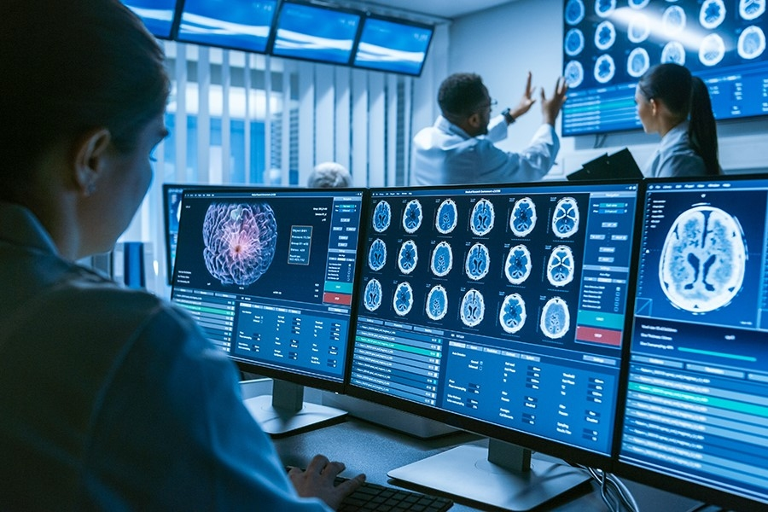

Caption:

Researchers demonstrated that medical AI systems can easily learn to recognize racial identity in medical images, and that this capability is extremely difficult to isolate or mitigate.

The miseducation of algorithms is a critical problem; when artificial intelligence mirrors unconscious thoughts, racism, and biases of the humans who generated these algorithms, it can lead to serious harm. Computer programs, for example, have [wrongly flagged](https://mit-serc.pubpub.org/pub/risk-prediction-in-cj/release/1) Black defendants [as twice as likely to reoffend](https://mit-serc.pubpub.org/pub/risk-prediction-in-cj/release/1) as someone who’s white. When an AI used cost as a proxy for health needs, it [falsely named](https://www.sciencedirect.com/science/article/pii/S2666389921002026) Black patients as healthier than equally sick white ones, as less money was spent on them. Even AI used to write a play relied on using [harmful stereotypes](https://time.com/6092078/artificial-intelligence-play/) for casting.

Removing sensitive features from the data seems like a viable tweak. But what happens when it’s not enough?

Examples of bias in natural language processing are boundless — but MIT scientists have investigated another important, largely underexplored modality: medical images. Using both private and public datasets, the team found that AI can accurately predict self-reported race of patients from medical images alone. Using imaging data of chest X-rays, limb X-rays, chest CT scans, and mammograms, the team trained a deep learning model to identify race as white, Black, or Asian — even though the images themselves contained no explicit mention of the patient’s race. This is a feat even the most seasoned physicians cannot do, and it’s not clear how the model was able to do this.

In an attempt to tease out and make sense of the enigmatic “how” of it all, the researchers ran a slew of experiments. To investigate possible mechanisms of race detection, they looked at variables like differences in anatomy, bone density, resolution of images — and many more, and the models still prevailed with high ability to detect race from chest X-rays. “These results were initially confusing, because the members of our research team could not come anywhere close to identifying a good proxy for this task,” says paper co-author Marzyeh Ghassemi, an assistant professor in the MIT Department of Electrical Engineering and Computer Science and the Institute for Medical Engineering and Science (IMES), who is an affiliate of the Computer Science and Artificial Intelligence Laboratory (CSAIL) and of the MIT Jameel Clinic. “Even when you filter medical images past where the images are recognizable as medical images at all, deep models maintain a very high performance. That is concerning because superhuman capacities are generally much more difficult to control, regulate, and prevent from harming people.”

In a clinical setting, algorithms can help tell us whether a patient is a candidate for chemotherapy, dictate the triage of patients, or decide if a movement to the ICU is necessary. “We think that the algorithms are only looking at vital signs or laboratory tests, but it’s possible they’re also looking at your race, ethnicity, sex, whether you're incarcerated or not — even if all of that information is hidden,” says paper co-author Leo Anthony Celi, principal research scientist in IMES at MIT and associate professor of medicine at Harvard Medical School. “Just because you have representation of different groups in your algorithms, that doesn’t guarantee it won't perpetuate or magnify existing disparities and inequities. Feeding the algorithms with more data with representation is not a panacea. This paper should make us pause and truly reconsider whether we are ready to bring AI to the bedside.”

The study, “[AI recognition of patient race in medical imaging: a modeling study](https://www.thelancet.com/journals/landig/article/PIIS2589-7500(22)00063-2/fulltext),” was published in *Lancet Digital Health*on May 11. Celi and Ghassemi wrote the paper alongside 20 other authors in four countries.

To set up the tests, the scientists first showed that the models were able to predict race across multiple imaging modalities, various datasets, and diverse clinical tasks, as well as across a range of academic centers and patient populations in the United States. They used three large chest X-ray datasets, and tested the model on an unseen subset of the dataset used to train the model and a completely different one. Next, they trained the racial identity detection models for non-chest X-ray images from multiple body locations, including digital radiography, mammography, lateral cervical spine radiographs, and chest CTs to see whether the model’s performance was limited to chest X-rays.

The team covered many bases in an attempt to explain the model’s behavior: differences in physical characteristics between different racial groups (body habitus, breast density), disease distribution (previous studies have shown that Black patients have a higher incidence for health issues like cardiac disease), location-specific or tissue specific differences, effects of societal bias and environmental stress, the ability of deep learning systems to detect race when multiple demographic and patient factors were combined, and if specific image regions contributed to recognizing race.

What emerged was truly staggering: The ability of the models to predict race from diagnostic labels alone was much lower than the chest X-ray image-based models.

For example, the bone density test used images where the thicker part of the bone appeared white, and the thinner part appeared more gray or translucent. Scientists assumed that since Black people generally have higher bone mineral density, the color differences helped the AI models to detect race. To cut that off, they clipped the images with a filter, so the model couldn’t color differences. It turned out that cutting off the color supply didn’t faze the model — it still could accurately predict races. (The “Area Under the Curve'' value, meaning the measure of the accuracy of a quantitative diagnostic test, was 0.94–0.96). As such, the learned features of the model appeared to rely on all regions of the image, meaning that controlling this type of algorithmic behavior presents a messy, challenging problem.

The scientists acknowledge limited availability of racial identity labels, which caused them to focus on Asian, Black, and white populations, and that their ground truth was a self-reported detail. Other forthcoming work will include potentially looking at isolating different signals before image reconstruction, because, as with bone density experiments, they couldn’t account for residual bone tissue that was on the images.

Notably, other work by Ghassemi and Celi led by MIT student Hammaad Adam has found that models can also identify patient self-reported race from clinical notes even when those notes are stripped of explicit indicators of race. Just as in this work, human experts are not able to accurately predict patient race from the same redacted clinical notes.

“We need to bring social scientists into the picture. Domain experts, which are usually the clinicians, public health practitioners, computer scientists, and engineers are not enough. Health care is a social-cultural problem just as much as it’s a medical problem. We need another group of experts to weigh in and to provide input and feedback on how we design, develop, deploy, and evaluate these algorithms,” says Celi. “We need to also ask the data scientists, before any exploration of the data, are there disparities? Which patient groups are marginalized? What are the drivers of those disparities? Is it access to care? Is it from the subjectivity of the care providers? If we don't understand that, we won’t have a chance of being able to identify the unintended consequences of the algorithms, and there's no way we’ll be able to safeguard the algorithms from perpetuating biases.”

“The fact that algorithms 'see' race, as the authors convincingly document, can be dangerous. But an important and related fact is that, when used carefully, algorithms can also work to counter bias,” says Ziad Obermeyer, associate professor at the University of California at Berkeley, whose research focuses on AI applied to health. “In our [own work](https://www.nature.com/articles/s41591-020-01192-7), led by computer scientist Emma Pierson at Cornell, we show that algorithms that learn from patients' pain experiences can find new sources of knee pain in X-rays that disproportionately affect Black patients — and are disproportionately missed by radiologists. So just like any tool, algorithms can be a force for evil or a force for good — which one depends on us, and the choices we make when we build algorithms.”

The work is supported, in part, by the National Institutes of Health.

# Is Quantum Computing the Future of Artificial Intelligence?

[**Mrinal Singh Walia**](https://www.analyticsvidhya.com/blog/author/mrinal41/)**— April 14, 2022**

[Artificial Intelligence](https://www.analyticsvidhya.com/blog/category/artificial-intelligence/) [Education](https://www.analyticsvidhya.com/blog/category/education/) [Intermediate](https://www.analyticsvidhya.com/blog/category/intermediate/)

This article was published as a part of the [Data Science Blogathon](https://datahack.analyticsvidhya.com/contest/data-science-blogathon-19/).

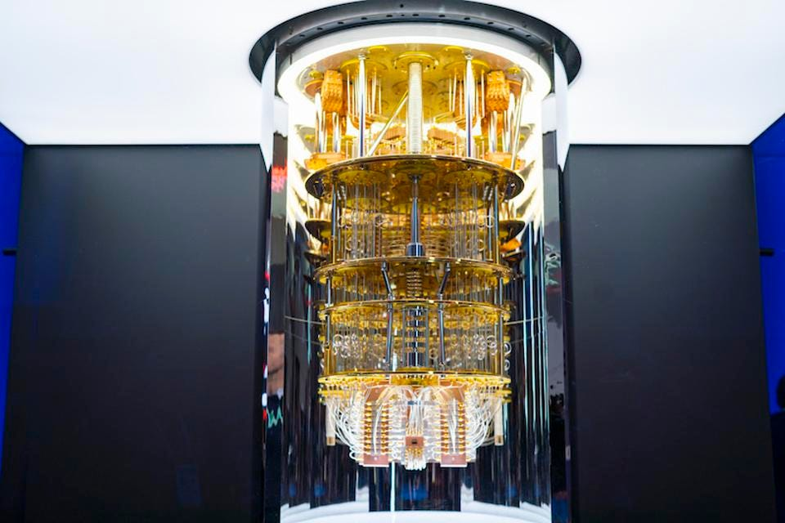

**Source**: Forbes.com

## Introduction

It is not hidden from the audience that [quantum computing](https://www.analyticsvidhya.com/blog/2018/12/datahack-radio-quantum-machine-learning/) is the future of data processing. Tech giants like IBM, Google, and Microsoft are all aggressively pursuing quantum computing technology for a good reason. The massive speedups and power savings of quantum computers will redefine what is possible in artificial intelligence and machine learning fields.

However, there is a disturbing lack of discussion around the implications of quantum computing for artificial intelligence. This article will explore the implications of quantum computing for artificial intelligence and why more people should be talking about it.

## What is Quantum Computing?

Quantum computing is a style of computing that relies on the principles of quantum mechanics to function. In classical computing, data is encoded in bits that can be either 1 or 0.

On the other hand, Quantum computing uses qubits that can be both 1 and 0 simultaneously. This allows many calculations to be done simultaneously, so quantum computing is powerful. It’s also why it’s seen as the future of artificial intelligence and data science.

## How is Quantum Computing Different from Classical Computing?

The essential dissimilarity between classical and quantum computing is that while classical computers use either 1 or 0, quantum computers use qubits, both 1 and 0 simultaneously. Quantum computing takes advantage of the features of quantum mechanics to process information using qubits.

These can represent a combination of 1 and 0, allowing for many calculations to be done simultaneously. Quantum computers are not subject to the same errors as classical computers due to their use of qubits. This makes them more reliable for sensitive applications, like those used in artificial intelligence.



##### India’s Largest Data Science Hiring Event

[Register for Free](https://datahack.analyticsvidhya.com/contest/job-a-thon-june-2022/?utm_source=blog&utm_medium=bannerbetweenarticle)

This allows them to explore many different solutions to a problem simultaneously, so quantum computers are powerful for simulating complex systems and machine learning tasks.

## What are the Advantages of Quantum Computing?

There are many advantages that quantum computing has over classical computing. One of the critical advantages of quantum computing is that it can solve problems much faster than classical computers.

This is because a quantum computer harnesses the features of both a particle and a wave, which allows it to explore many different solutions at once, which is called “quantum parallelism.”.

Additionally, quantum computers are not affected by noise and can function in extreme conditions, perfect for AI and machine learning applications. Another advantage is that quantum computers can overcome errors in traditional computing systems.

Finally, quantum computers can store and process large amounts of data, which is essential for artificial intelligence and machine learning models.

## Drawbacks of Quantum Computing

Besides all its benefits and advantages, people are afraid to try quantum computing, and the reasons are valid. Due to its robust nature, it is exceedingly hard to engineer, build and program a quantum computer. It is no wonder how difficult it will be to train an AI model to detect objects in an image.

Due to its complex nature, quantum computers and programs are crippled by errors in noise, faults, and loss of quantum coherence. And as the number of qubits multiplies, the isolation of these qubits from their environment becomes extremely difficult to sustain, and decoherence is bound to happen that is bringing in a bunch of errors.

Hence, the characteristics that make quantum systems powerful also make them delicate and cause the whole system to fall apart.

## Why is Quantum Computing the Future of Artificial Intelligence?

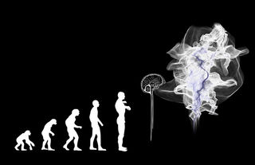

**Source:**[**Psychology.com**](https://www.psychologytoday.com/us/blog/the-future-brain/201901/how-ai-and-quantum-computing-may-alter-humanity-s-future)

In classical computing, bits are either one or zero. However, a quantum bit or qubit can be simultaneously one and zero in quantum computing, which opens up a whole new realm of possibilities for computing power.

Quantum computers can crack problems much quicker than classical computers because they can try several solutions simultaneously. They’re also not constrained by the same limitations as classical computers, meaning they can solve currently impossible problems.

This makes quantum computing the perfect candidate for powering artificial intelligence. The vast amounts of data processed by AI systems require enormous computational power. Quantum computers have the potential to provide that power and thus enable AI to reach its full potential.

## Real-life Applications

This section lets us see some real-life practical applications where quantum computing in AI can change the future.

**1. Financial Services & Healthcare:**This is one field where quantum computing, with the help of AI, is helping solve many complexities with its speed and specificity.

**2. Solving Mathematical Problems:**Many types of research are going on in maths, science, and history. With the help of quantum computers, it can be solved in a much lower period. For example, if a classical computer takes 10 years to solve a mathematical problem, quantum computers, with the help of AI, can solve that in less than a month.

**3. Fraud Detection & CyberSecurity:**With the help of AI algorithms, Quantum computers are helping agencies enhance their protection and increase the security on the internet.

## Why is Quantum Computing still Unknown to Many?

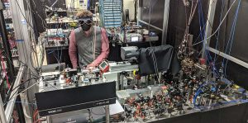

**Source:**[**BostonGlobe.com**](https://www.bostonglobe.com/2021/11/17/business/boston-startup-says-its-made-quantum-leap-computing/)

There are a few possible explanations for why quantum computing isn’t being discussed more in the AI and ML communities. One possibility is that people are unsure how to apply quantum computing to their work. Another possibility is that the potential applications of quantum computing are so vast and far-reaching that people are hesitant to get too excited about it until there’s a more concrete plan for how it will be used.

## Conclusion

Quantum computing is a technology that is quickly gaining traction due to its potential applications in various industries. Despite this, there is a lack of chitchat around quantum computing and its role in the future of artificial intelligence.

Quantum computers can decode problems much faster than classical computers and can be used to model large-scale systems and molecules. They can also handle large amounts of data, which is essential for training artificial intelligence models. As quantum computing becomes more accessible, it will play a vital role in developing artificial intelligence and future applications.

Hope you enjoyed reading my article. If you would like to discuss this further, please comment below. Will be happy to have a fruitful discussion on it.

**The media shown in this article is not owned by Analytics Vidhya and is used at the Author’s discretion.**